

**CM : 1257 CCB METER MIGRATION FROM CCB TO WAM**

**System Design Document**

**APDU-XXX.0.0**

Revision 01

| **DOCUMENT VERSION HISTORY** | | | | |
| --- | --- | --- | --- | --- |
| **Version Number** | **Version Date** | **Revised by** | **Description** | **Filename** |
| 1.0 | 04-14-2023 | Bryl Joseph Apas | Draft System Design Document | APDU.ADD.SystemDesign. Template |

**Table of Contents**

**Section 1 Introduction** **4**

1.1 Purpose and Scope 4

1.2 Project Executive Summary 4

**Section 2 System Design** **5**

2.1 Data Design 5

2.2 Application Design 6

2.3 Technology Design 7

# **Section 1** Introduction

Management sees the need to track the meter from cradle to grave. Thus, tracking would also establish the lifecycle of a meter.

Meter data currently resides in three databases, to wit, ebs-inventory, wam component, ccb meter. While there are 3 sources, only WAM component has the functionality to track movement of the meter.

## **1.1 Purpose and Scope**

* WAM Component as the single source of truth while addressing the whereabouts of a meter at any point in time.
* To ensure meter is tracked

## **1.2 Project Executive Summary**

The CM 1257 : CCB Meter Migration from CCB to WAM has a job running twice every month. In the job it calls the procedure for interfacing the meters from CCB into WAM

The Meter Migration fetches meters in CCB filtering the data based on the parameters in BRD. The meters consists of installed and removed meters to be migrated in WAM

# **Section 2** System Design

## **2.1 Data Design**

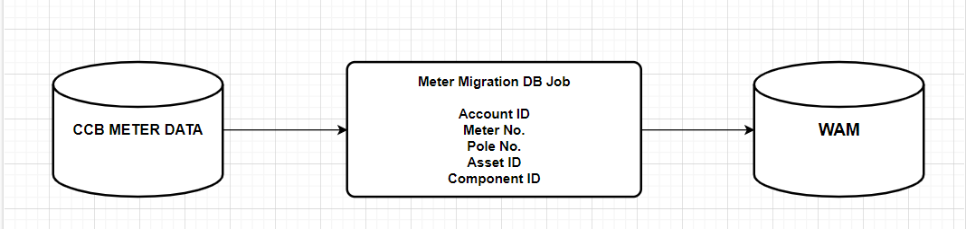

## **2.2 Application Design**

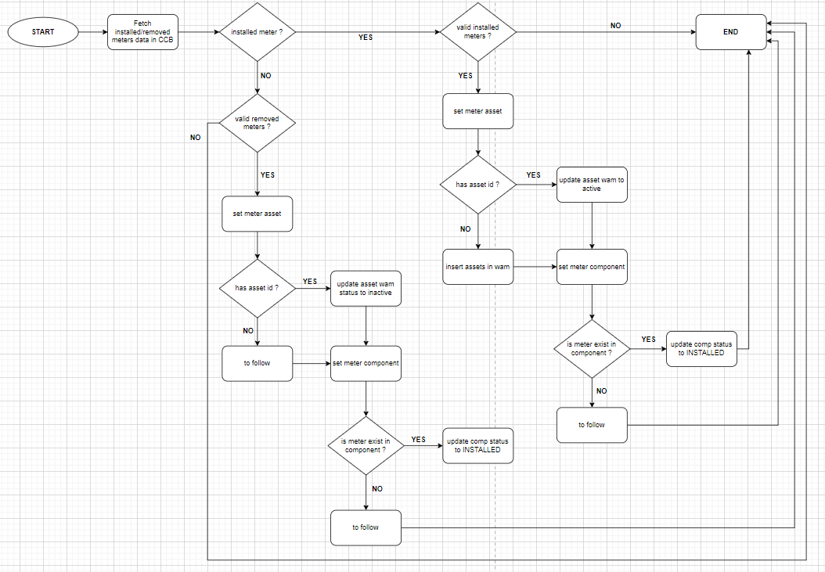

## 

## **2.3 Technology Design**

On this CR, we have here a ESB Inhouse Database where DB Jobs fetches package to run

| Database : UAT INHOUSE VECO  IP : cumulus-dbuat.aboitiz.net  Port : 1521  Service Name : tamarong.aboitiz.net  Schema : esb | Database : UAT INHOUSE DLPC  IP : 10.110.150.44  Port : 1521  Service Name : DUHOL.ABOITIZ.NET  Schema : esb |
| --- | --- |
| Database : UAT INHOUSE CLPC  IP : 10.110.150.44  Port : 1521  Service Name : molmol.aboitiz.net  Schema : esb | Database : UAT INHOUSE SEZC  IP : 10.110.150.45  Port : 1521  Service Name : sardinas.aboitiz.net  Schema : esb |

